How to find embed code to get the 2020 Catholic Appeal video on your website!
Embedding allows you to take your video — or someone else's video — and post it on a web page outside of Vimeo. For example, you can embed a video on your website and then people can watch your video there without having to visit Vimeo.
- Go to the vimeo site and find the 2020 Catholic Appeal video. Here is the link: https://vimeo.com/389511915
- Click the “Share” button underneath the video

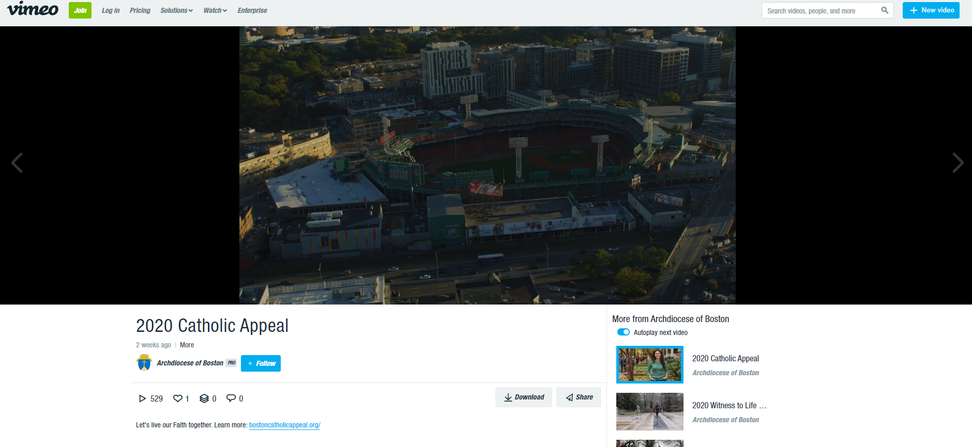
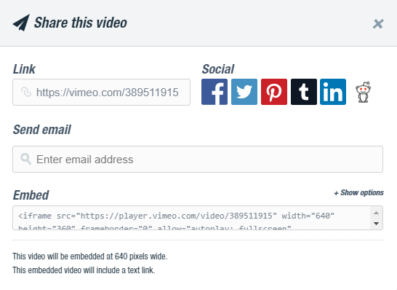
- This box will appear:

- Go into the text box under “Embed” and copy all of the text.
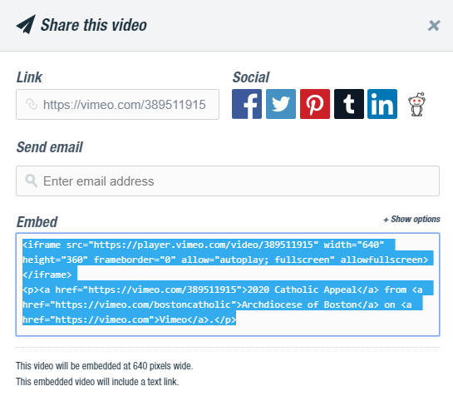

- Paste that text into your website and the video will be embedded!

For more information visit: https://vimeo.zendesk.com/hc/en-us/articles/224969968-Embedding-videos-overview

Thank you for sharing the 2020 Catholic Appeal video!

