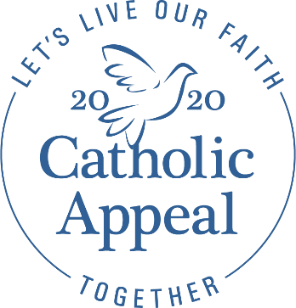

BULLETIN ANNOUNCEMENTS

LAUNCH WEEKENDS
ANNOUNCEMENT WEEKEND: March 7/8
Next weekend, the Catholic Appeal will be launched in all parishes throughout the Archdiocese. In preparation, we invite you to prayerfully consider making a generous gift that will benefit both our parish and the many ministries that serve the 283 parishes, 110 schools, and 144 communities throughout the Archdiocese. Please take a moment today to look through the Catholic Appeal insert to learn more about the meaningful impact your gift will have. This is our Church, and when you support the Appeal, you support us.

To learn more about the Catholic Appeal, or to make your gift online, please visit the new Appeal website at bostoncatholicappeal.org, where you can also view the 2020 Catholic Appeal video that was shown at Masses this weekend.

COMMITMENT WEEKEND: March 14/15
Today in every parish across the Archdiocese, Cardinal Seán calls on us to support the annual Catholic Appeal. The success of the Appeal is vital in funding the 51 central ministries that provide assistance to our parishes, schools, and communities in a variety of ways. Every gift, regardless of the size, is meaningful and can make an impact. Your participation in this weekend’s campaign is very much appreciated by our parish and the thousands that are served through the Archdiocesean Central Ministries. Thank you for your generosity and support of the 2020 Catholic Appeal this weekend.

POST-LAUNCH WEEKEND
March 21/22
Through your support of the 2020 Catholic Appeal, we are able to bring the Gospel message to life in our parishes, Catholic schools, and communities. If you have yet to make a pledge to this year’s Catholic Appeal, please complete a pledge form available in the back of the church or visit bostoncatholicappeal.org. Thank you for your prayers and support.

Or

The PARISH NAME 2020 Catholic Appeal campaign is off to a wonderful start! With $XX already pledged, we are at X% of goal. The generous outpouring of support from so many of our wonderful parishioners helps sustain the important ministries that make PARISH NAME a vibrant place of worship. If you have yet to give, please pick up a pledge form at the back of the church or visit bostoncatholicappeal.org. Thank you for your prayers and support.

Or

Thank you to all who have participated in PARISH NAME’s 2020 Catholic Appeal campaign. Through the generosity of Catholics like you, the Catholic Appeal strengthens the ministries that serve our Archdiocese and help us live our faith together. To make a pledge to the Catholic Appeal, please visit bostoncatholicappeal.org or pick up a pledge form at the back of the church. Thank you for your prayers and support. Stay tuned for continued updates regarding our parish’s 2020 Catholic Appeal!

PRAYER OF THE FAITHFUL
all options for Commitment Weekend only

For the ministries supported by the Catholic Appeal that directly benefit PARISH NAME, may these ministries be blessed by generous support from the PARISH NAME community.

In gratitude for all volunteers and donors to the 2020 Catholic Appeal from PARISH NAME, may their service and generosity deepen their faith, and may they take comfort knowing that through their goodness and leadership, they have helped so many encounter Christ through the ministries of the Archdiocese.

That our gifts to the Catholic Appeal will enable its many ministries to spread the Gospel message and give aid and comfort to those in need here at PARISH NAME and throughout our Church.

That through supporting the Catholic Appeal, we may be strengthened in unity as we work together to help all of us here at PARISH NAME live our faith together.

Clip art to add to your bulletin

