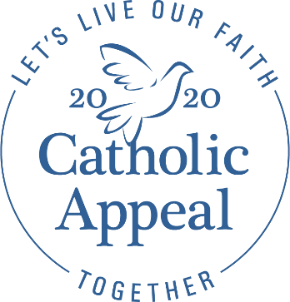

BULLETIN ANNOUNCEMENT
While many aspects of our life have come to a standstill, the work of our diocesan and parish ministries continues as we strive to meet the needs of those who are relying on our guidance and assistance. The sick and homebound continue to receive spiritual support and information over the phone from the Archdiocese’s Faith Community Nurses and Chaplains program. Our Pregnancy Help Centers continue to provide resources for women facing crisis pregnancies. Those suffering from addiction still need support and guidance and many have greater need for counseling and spiritual support during this time of heightened anxiety.
The suspension of Masses in the Archdiocese—a difficult but necessary public health precaution—has postponed the launch of the Catholic Appeal in our parishes. This presents a unique challenge in continuing the work of our ministries as the Appeal provides nearly half of the funding for these efforts. With the knowledge that many of you are also facing challenging financial realities, and with concern for the people we serve, your prayerful consideration is greatly appreciated. Your support will make a significant difference as we attempt to continue serving the Catholic faithful and all our brothers and sisters in need. To learn more about Your Church at Work or to make a donation, visit www.bostoncatholicappeal.org Thank you!
Clip art to add to your bulletin

