Summer Launch for 2020 Catholic Appeal
Throughout the month of August, we hope that you will support the Catholic Appeal at your parish. Below are some suggested messaging for:
- Bulletin Announcements
- Catholic Appeal Clip Art
- Prayers of the Faithful
- Mass Announcement / Witness Talk

BULLETIN ANNOUNCEMENTS
Sample 1
Due to the shutdown of Churches for COVID-19, parishes were unable to launch the 2020 Catholic Appeal this past March with an in-pew presentation. However, as the work of our Church has continued amidst the pandemic, the more than 50 ministries funded by the Catholic Appeal are in need now more than ever. The success of the Appeal is vital in funding these ministries that provide assistance to our parishes, schools, and communities in a variety of ways. Please consider making your gift to the 2020 Catholic Appeal in one of the following ways:
- If you receive a letter or email, respond using the pledge card or donation options.
- Visit bostoncatholicappeal.org to give online
- Return the envelope in this bulletin
Every gift, regardless of the size, is meaningful and can make an impact. Your participation in our parish Appeal is very much appreciated by our parish and the thousands that are served through the Archdiocesan Central Ministries. This is our Church and when you support the Appeal, you support us!

Sample 2
Even in the midst of a global pandemic, service to others remains core to the work of our Church.
- Our COVID response team of priests is anointing the sick in hospitals.
- Our Central Ministries continue to care for so many in need.
- Our Risk Management office continues to provide guidance for parishes and schools.
This is Our Church. Funded by the Catholic Appeal. Please prayerfully consider making a gift to the 2020 Catholic Appeal in one of the following ways.
- If you receive a letter or email, respond using the pledge card or donation options.
- Visit bostoncatholicappeal.org to give online
- Return the envelope in this bulletin
Your support will make a significant difference as we continue serving the Catholic faithful and all our brothers and sisters in need. To learn more about Your Church at Work or to make a donation, visit www.bostoncatholicappeal.org Thank you!

Sample 3
While many aspects of our life have come to a standstill, the work of our ministries continues as we strive to meet the needs of those who are relying on our guidance and assistance. The sick and homebound continue to receive spiritual support and information over the phone from the Archdiocese’s Faith Community Nurses and Chaplains program. Our Pregnancy Help Centers continue to provide resources for women facing crisis pregnancies. Those suffering from addiction still need support and guidance and many have greater need for counseling and spiritual support during this time of heightened anxiety.
Your support of the Catholic Appeal ensures that these programs and services continue. With the knowledge that many of you are also facing challenging financial realities, and with concern for the people we serve, we hope that you will prayerfully consider making your gift to the 2020 Catholic Appeal in one of the following ways:
- If you receive a letter or email, respond using the pledge card or donation options.
- Visit bostoncatholicappeal.org to give online
- Return the envelope in this bulletin
To learn more about Your Church at Work or to make a donation, visit www.bostoncatholicappeal.org
Thank you!

Clip Art samples for your bulletin or website.

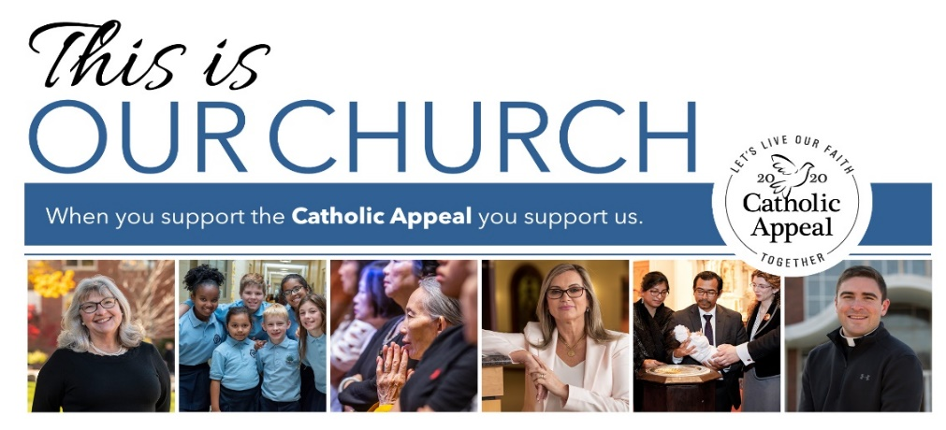

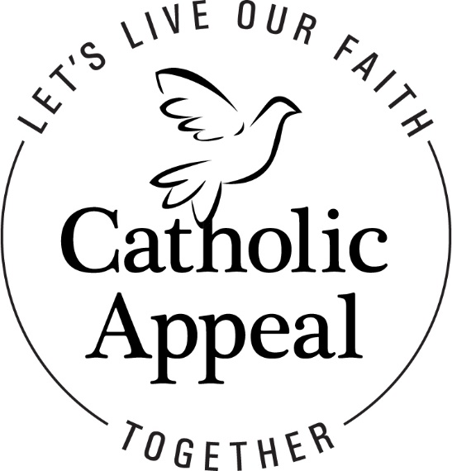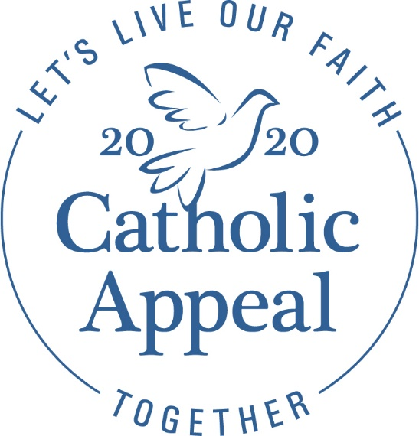

Options for Prayers of the Faithful
The Catholic Appeal, in addition to meeting the financial needs of our Church, calls one another to actively practice our faith. Prayer is vital in the conversion of the heart, which leads people to give generously to serve the needs of others.
The following are some sample Prayers of the Faithful that you may want to consider adding to your Parish liturgies:

That our gifts to the Catholic Appeal will enable its many ministries to spread the Gospel message and give aid and comfort to those in need here at PARISH NAME and throughout our Church, especially during these uncertain times.

That through supporting the Catholic Appeal, we may be strengthened in unity as we work together to help all of us here at PARISH NAME live our faith together.

For the ministries supported by the Catholic Appeal that directly benefit PARISH NAME, may these ministries be blessed by generous support from the PARISH NAME community.

That we may see the work of the Catholic Appeal as an opportunity to extend our love and service beyond the boundaries of our parish and local community. We pray to the Lord.

For all those in need, that they may find guidance and assistance from the many services available through our generous support of the Catholic Appeal. We pray to the Lord.

MASS ANNOUNCEMENT
Sample 1

Due to the shutdown of Churches for COVID-19, parishes were unable to launch the 2020 Catholic Appeal this past March with an in-pew presentation. However, as the work of our Church has continued amidst the pandemic, the ministries funded by the Catholic Appeal are in need now more than ever. These ministries not only help our parish, but they help the greater community. Please consider making your gift to the 2020 Catholic Appeal in one of the following ways:
- If you receive a letter or email, use the return envelope or donations options
- Visit bostoncatholicappeal.org to give online
- Take an envelope from the bulletin or from volunteers handing them out as you exit the Church/worship space and return next week.
Every gift is meaningful and can make an impact. Your participation is very much appreciated by our parish and the thousands that are served through the Archdiocesan Central Ministries. Thank you for your generosity and support of the 2020 Catholic Appeal.

Witness Talk
Sample 2
Good Morning / Afternoon / Evening:
Thank you for letting me take just a few moments of your time to share some thoughts with you on the importance—and impact—of making a gift to the 2020 Catholic Appeal. A long, long, long time ago, back in March, I stood before you to talk about the important ministries supported by the Catholic Appeal. As we were preparing to launch, our participation as a parish was cut short when Masses were stopped due to Covid19.
Since that time, our parish has relied on the many resources offered by the Archdiocese to chart a path forward through this crisis. The Archdiocese has worked tirelessly with parishes to:
- Secure government funding to maintain our parish staffing needs
- Provide us with guidance, resources, and supplies to safely restart Mass
- Offered webinars and tools to share ideas to maintain our virtual connections and continue our evangelization efforts.
Whether you are attending Mass in person or watching from home, I invite you to join me in supporting the Catholic Appeal. We recognize that many of you may be navigating your own financial challenges but ask for your prayerful consideration of a gift to the 2020 Catholic Appeal at whatever level is comfortable for you.
If you have not received a Catholic Appeal letter or email request, donations can be made on line at www.bostoncatholicappeal.org
For those of you who have already pledged your support of the 2020 Catholic Appeal. Thank you! Your gift is so important.
On behalf of Cardinal Seán and Msgr./Fr. ¬_________ I thank you so much for your time and consideration of this important request.

