2021 Catholic Appeal
BULLETIN ANNOUNCEMENTS

2021 Catholic Appeal Update
I am pleased to share that even during these difficult times, PARISH NAME has raised $X toward our 2021 Catholic Appeal goal of $X. Our heartfelt thanks to all who have helped make our campaign a success so far. Whether you are attending Mass in person or watching from home, I invite you to join me in supporting the Catholic Appeal. We recognize that many of you may be navigating your own financial challenges but ask for your prayerful consideration of a gift to the 2021 Catholic Appeal at whatever level is comfortable for you. If you have not received a Catholic Appeal letter or email request, donations can be made on line at www.bostoncatholicappeal.org
Every gift, regardless of the size, is meaningful and can make an impact. Your participation in our Appeal is very much appreciated by our parish and the thousands that are served through the Archdiocesan Central Ministries.
This is our Church and when you support the Appeal, you support us!

2021 Catholic Appeal Update
The 2021 Catholic Appeal campaign is well underway at PARISH NAME. Together, we have raised $X toward our parish goal of $X. Our heartfelt thanks to all who have participated, especially during this difficult year. Your generosity will benefit hundreds of pastoral, charitable, and educational programs at work within the Archdiocese of Boston, and at PARISH NAME.
We recognize that many of you may be navigating your own financial challenges but ask for your prayerful consideration of a gift to the 2021 Catholic Appeal at whatever level is comfortable for you. Every gift, regardless of the size, is meaningful and can make an impact. If you have not received a Catholic Appeal letter or email request, donations can be made on line at www.bostoncatholicappeal.org Your participation in our parish Appeal is very much appreciated by our parish and the thousands that are served through the Archdiocesan Central Ministries.
This is our Church and when you support the Appeal, you support us!

Clip Art samples for your bulletin or website.

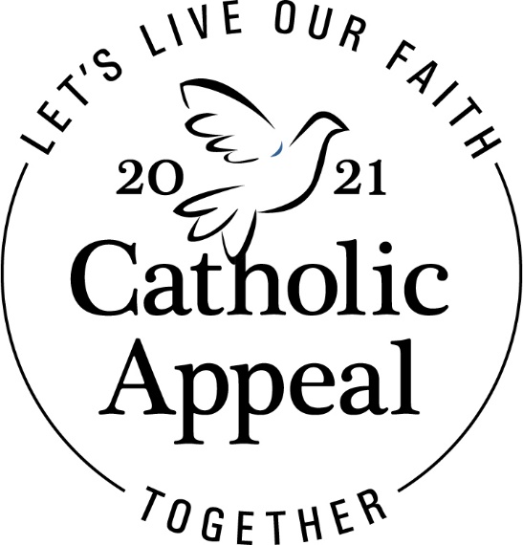
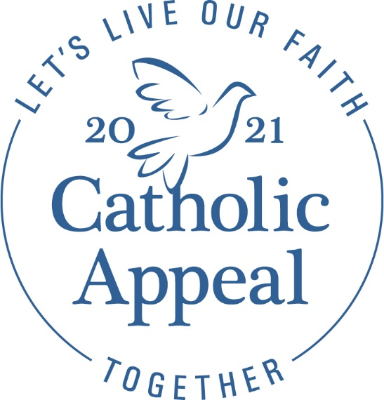

Options for Prayers of the Faithful
The following are some sample Prayers of the Faithful that you may want to consider adding to your Parish liturgies:

That our gifts to the Catholic Appeal will enable its many ministries to spread the Gospel message and give aid and comfort to those in need here at PARISH NAME and throughout our Church, especially during these uncertain times.

That through supporting the Catholic Appeal, we may be strengthened in unity as we work together to help all of us here at PARISH NAME live our faith together.

For the ministries supported by the Catholic Appeal that directly benefit PARISH NAME, may these ministries be blessed by generous support from the PARISH NAME community.

That we may see the work of the Catholic Appeal as an opportunity to extend our love and service beyond the boundaries of our parish and local community. We pray to the Lord.

For all those in need, that they may find guidance and assistance from the many services available through our generous support of the Catholic Appeal. We pray to the Lord.

