2021 Catholic Appeal:
Sample Bulletin Announcement
Please use these sample announcements and clip art to thank and inform your parishioners about the Catholic Appeal. Please be sure to have blue in-pew envelopes available at the back of the church.
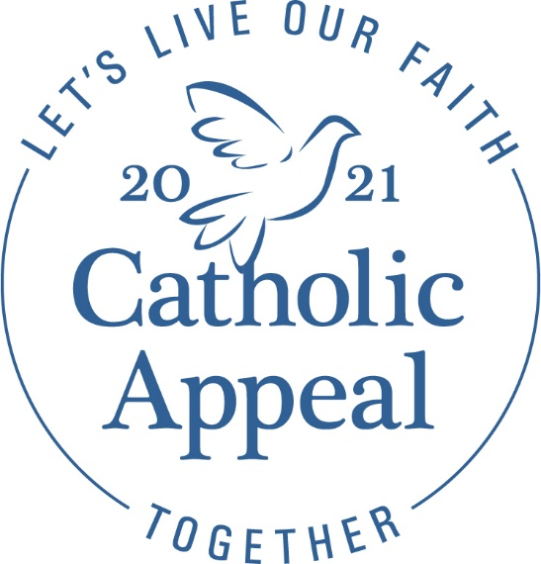
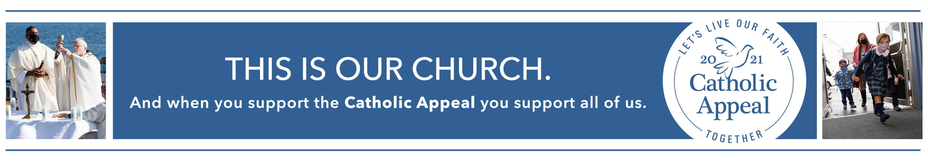

HELP US CLOSE OUT APPEAL CAMPAIGN BY A CERTAIN DATE

I am pleased to share that PARISH NAME has raised $X toward our 2021 Catholic Appeal goal of $X. Thank you to all who have helped make our campaign a success so far. If you have yet to give, we need your help! Please give today to help us reach goal by XX/XX/XX. Gifts can be made online at www.bostoncatholicappeal.org or by completing a pledge form available in the back of the church.

REPORTING PROGRESS TOWARD CATHOLIC APPEAL GOAL

Our 2021 Catholic Appeal campaign is well underway at PARISH NAME. So far, X parishioners have participated, and together, we have raised $X toward our parish goal of $X. Thank you to all who already have participated. Your generosity will benefit hundreds of pastoral, charitable, and educational programs at work within the Archdiocese of Boston, and at PARISH NAME. With $X left to raise, we need the participation of every parishioner. If you have yet to participate in the 2021 Catholic Appeal, please pledge online at www.bostoncatholicappeal.org or complete a pledge form available in the back of the church.

SURPASSED 2021 CATHOLIC APPEAL GOAL—THANK YOU!

Congratulations! PARISH NAME has surpassed its 2021 Catholic Appeal goal of $X. I am truly grateful to the X parishioners and families that helped us reach our goal. The Catholic Appeal provides critical funding to hundreds of pastoral, charitable, and educational programs that impact tens of thousands throughout our Archdiocese. Thank you for responding to Cardinal Seán’s call to witness more clearly the depths of God’s love for each one of us through this important effort.

2021 Annual Catholic Appeal
Today we wish to recognize those who not only support our parish, but also have made a gift or pledge to the 2021 Annual Catholic Appeal. On behalf of those who will be served by your contributions, thank you to all who have already completed their pledge payments, as well as those who are still making payments.
For those of you who have not had an opportunity to make a pledge or a gift this year but wish to support the ministries and services funded by the Catholic Appeal, please contact the Catholic Appeal Office at (617)-779-3700 or online at www.bostoncatholicappeal.org. Remember that when our Parish exceeds its goal, a percentage of any additional funds received is returned for use in our Parish.
When each of our individual gifts are combined with the gifts of thousands of other parishioners throughout the Archdiocese, each contributor makes a very real difference in the ability of the Archdiocese to provide ministries and services. Thank you again for your support.

October Bulletin Announcement:

2021 Annual Catholic Appeal
Gifts of our time, talent and treasure to our Parish and our Archdiocese are an important part of our commitment to stewardship of God’s gifts. Those who have contributed to the 2021 Catholic Appeal are expressing their gratitude for God’s gifts to them and are providing critical resources necessary to continue the ministries and services of the Archdiocese.
On behalf of Cardinal Seán and the many beneficiaries of the Catholic Appeal, thank you for completing your pledge payments. Every gift is important and appreciated. Remember that when our Parish exceeds its goal, a percentage of the additional funds received are returned for use in our Parish.
Those who are paying pledges to the Appeal are reminded that the last pledge billing will be mailed in December. If you wish to make a contribution to the 2021 Annual Catholic Appeal, please contact the Catholic Appeal at (617)-779-3700 or online at www.bostoncatholicappeal.org

November Bulletin Announcement:
2021 Annual Catholic Appeal
Each year, thousands of households throughout the Archdiocese support the Catholic Appeal. Their gifts are given to help our neighbors in our community and around the world. Just one more pledge billing will be sent before the conclusion of the 2021 Catholic Appeal of the Archdiocese of Boston. On behalf of those who work in or benefit from the funded ministries and services, thank you to those of you who have made a gift or completed your pledge payments. Remember that when our Parish exceeds its goal, a percentage of the additional funds received are returned for use in our Parish.
Each gift, when combined with the gifts of thousands of other parishioners throughout the Archdiocese, makes a very real difference. Thank you!

December Bulletin Announcement:
2021 Catholic Appeal
The 2021 Annual Catholic Appeal is coming to a close. If you still have a pledge balance, please complete your pledge payments as soon as possible. For those who make charitable contributions at the end of the year, please consider gifts to your Parish and to the Annual Catholic Appeal. Your financial support is greatly appreciated.
On behalf of Cardinal Seán, our Parish Appeal Leadership, Parish staff, and myself, thank you for supporting your neighbors throughout the Archdiocese of Boston. Every gift is important and appreciated.
If you have not made a gift as yet and you wish to be part of the 2021 Catholic Appeal, it’s not too late. Please take an envelope from the back of the church or visit our website: www.bostoncatholicappeal.org

Prayers of the Faithful
The Annual Catholic Appeal, in addition to meeting the financial needs of our Church, calls one another to actively practice our faith. Prayer is vital in the conversion of the heart, which leads people to give generously to serve the needs of others.
The following are some sample Prayers of the Faithful that you may want to consider adding to your Parish liturgies:
• That we may see the work of the Annual Catholic Appeal as an opportunity to extend our love and service beyond the boundaries of our parish and local community. We pray to the Lord.
• For all those in need, that they may find guidance and assistance from the many services available through our generous support of the Annual Catholic Appeal. We pray to the Lord.
• That the Holy Spirit may continue to guide the work of the Church throughout our Archdiocese, and that Christ’s message of love may be realized by all. We pray to the Lord.
• That as we participate in the 2021 Annual Catholic Appeal to help others, we give thanks to our God for the gifts and blessings we have received. We pray to the Lord.
• For all contributors to Annual Catholic Appeal, that their generosity will give them joy and peace. We pray to the Lord.

