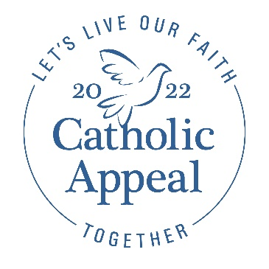
Post-Launch Bulletin Announcements and Ads
Please use the announcements below to update your parishioners about your parish’s 2022 Catholic Appeal campaign. Working these announcements into your pastor letter at the beginning of your bulletin is most impactful for your parishioners. Be sure to keep plenty of envelopes at the back of the Church to encourage giving.

NOTE: Remember to continue using the bulletin banner and/or box ads (found on the “For Parishes” tab at www.bostoncatholicappeal.org along with translations) which can be included with one of the below announcements or as a stand-alone ad.

Bulletin Announcement Option #1
Faith in Action, It All Starts with You
I am pleased to share that our parish has raised $XX toward our 2022 Catholic Appeal goal of $XX. Our heartfelt thanks go to all who have helped make our campaign a success so far. If you have not had the opportunity to support the Appeal yet, I invite you to make your gift today to help us reach our goal. Pick up an envelope at the back of the church or make an on-line donation at www.bostoncatholicappeal.org. Your participation in our Appeal is appreciated by our parish and all those who are served by the ministries funded by the Appeal that put faith into action to support all of our parishes, schools, and communities. Thank you.

Bulletin Announcement Option #2
Faith in Action, It All Starts with You
We are so grateful to all of you who have helped launch a successful 2022 Catholic Appeal campaign here at PARISH NAME. We have raised $XX so far, which means we are at XX% of our goal. If you have not had a chance to do so, please consider making your gift to the Appeal today by picking up an envelope at the back of the church or make an on-line donation at www.bostoncatholicappeal.org. Participation from every household in the parish is important and every gift makes a meaningful difference in putting faith into action to support the parishes, schools, and communities within our Archdiocese. Thank you.

Ready to use Bulletin Ads: These can be included with your bulletin announcement or as a stand along ad in your bulletin. Jpg versions in multiple languages are available on the “For Parishes” tab at www.bostoncatholicappeal.org Be sure to test the QR code before printing to ensure the format was not distorted.
