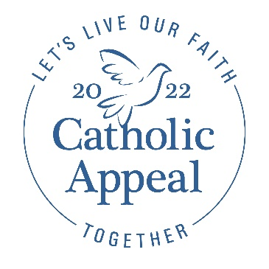
Mid-Appeal Bulletin Announcements
& Prayers of the Faithful

Below are bulletin announcements to inform, encourage, and thank your parishioners, as well as sample prayers of the faithful for you to incorporate into your celebration of Mass.

Consider working the announcements into your pastor letter at the beginning of your bulletin, as that is the most impactful way to get these messages across to your parishioners. Also, be sure to keep plenty of envelopes at the back of the Church to encourage giving.

A bulletin banner and/or box ads (sample banner below) can be found at the “For Parishes” tab at www.bostoncatholicappeal.org along with translations. Consider using these with an announcement or as a stand-alone ad.

SAMPLE BANNER AD:

BULLETIN ANNOUNCEMENT OPTIONS (ASKS):

The PARISH NAME 2022 Catholic Appeal campaign is off to a wonderful start! With $XX already pledged, we are at XX% of goal. The early outpouring of generosity is so appreciated and helps support the important ministries that make PARISH NAME a vibrant parish community. If you have yet to give, please pick up a donation envelope from the back of the church or visit bostoncatholicappeal.org/donate-now. Thank you for your prayers and support.

I am pleased to share that PARISH NAME has raised $XX toward our 2022 Catholic Appeal goal of $XX. Thank you to all who have contributed so far. If you have yet to give, we need your help! Please give today to help us reach goal by XX/XX/XX. Gifts can be made online at bostoncatholicappeal.org/donate-now or by picking up a donation envelope from the back of the church. Participation from every household is important and every gift—no matter the amount—makes a meaningful difference in putting faith into action to support the parishes, schools, and communities within our Archdiocese. Thank you.

We are so grateful to all those who have participated in the 2022 Catholic Appeal campaign here at PARISH NAME. We have raised $XX so far, which means we are at XX% of our goal. If you have not had a chance to do so, please consider making your gift to the Appeal today by picking up an envelope at the back of the church or visiting bostoncatholicappeal.org/donate-now. Participation from every household is important and every gift makes a meaningful difference in putting faith into action to support the parishes, schools, and communities within our Archdiocese. Thank you.

The 2022 Catholic Appeal campaign is well underway at PARISH NAME. So far, XX parishioners have participated, and together we have raised $XX toward our parish goal of $XX. Thank you to all who have contributed—your generosity makes a meaningful difference in putting faith into action to support the parishes, schools, and communities within our Archdiocese. With $XX left to raise, participation from every parishioner is vital. If you have yet to make your gift, please visit bostoncatholicappeal.org/donate-now or pick up a donation envelope from the back of the church. Thank you.

BULLETIN ANNOUNCEMENT OPTION (THANK YOU):

Congratulations! PARISH NAME has surpassed our 2022 Catholic Appeal goal of $XX. I am truly grateful to the XX parishioners and families that helped us reach this important milestone. The Catholic Appeal makes a meaningful difference in putting faith into action to support the parishes, schools, and communities within our Archdiocese. Thank you for your generosity and commitment to our parish and to our Church.

SAMPLE PRAYERS OF THE FAITHFUL:

That our gifts to the Catholic Appeal will enable the many ministries throughout the Archdiocese to put faith into action and support all those in need.
That through our support of the Catholic Appeal, we may be strengthened and uplifted as we live our faith together here at PARISH NAME.

