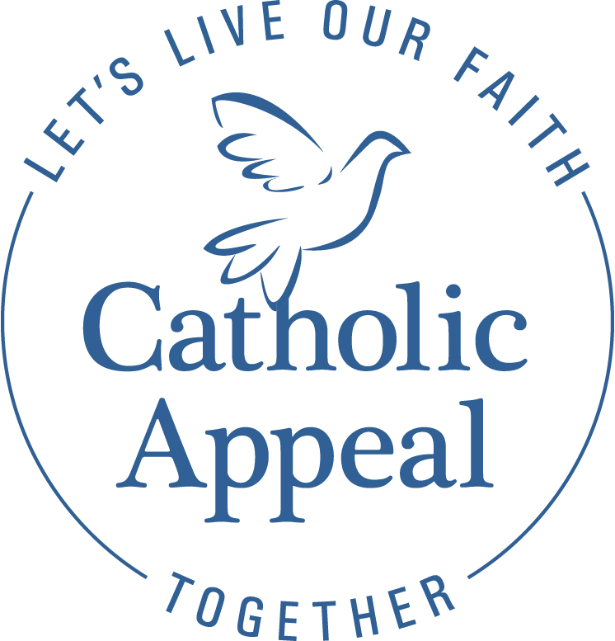
2022 Catholic Appeal
Summer Campaign

Thank you for our continued support of the Catholic Appeal.

Summer is a perfect opportunity to make a final outreach to close your Catholic Appeal Campaign. With our final letter from Cardinal Sean being mailed August 15th, your additional support can help boost the success of this mailing and encourage parishioner participation.

Your parishioners may be away on vacation, but they remain connected to your parish via social media, email or even livestreaming Mass. Be sure to reach out in various ways for the greatest impact.

- Conduct an In-Pew request: It’s not too late!
- Pick a weekend: We suggest the weekend of 8/20, but check your calendar for a weekend in August that works best for your parish.
- Ask parishioners to use the In- Pew envelopes to make a donation. The envelopes can be handed out at Mass, inserted into a bulletin or left at the back of the Church to pick up on their way home. Email Catholic_Appeal@rcab.org if you need additional envelopes.

- Provide an update from the pulpit on progress to date and request support from those who have yet to make a gift or pledge.

Sample Pulpit Announcement:

Back in March we launched our Catholic Appeal Campaign here at XXX parish. The response has been enthusiastic with our parish raising $XX towards our goal of $xx. Thank you. The Catholic Appeal provides an opportunity for all of us to make a commitment to the larger Church and the many ministries that support so many throughout our Archdiocese. Your generosity to the Annual Catholic Appeal helps to lead the way in the Church’s efforts to care for the poor, improve our ability to identify and treat mental illness challenges (particularly among our young people), bolster our schools and faith communities – and much more.
For those of you who have already given, Again, thank you. Your generousity provides much needed resources and care for thousands throughout our Archdiocese. If you are able, I hope you will consider renewing your support this year. Our parishes, schools and ministries rely on the generosity of the community to continue their work.
To make a donation, please use the In-Pew envelope at the back of the church, respond to the letter from Cardinal Sean or scan the QR code in our bulletin this week. Your support of the Catholic Appeal has never been more important. Thank you for your prayerful consideration of my request.

- Include an Appeal announcement and / or bulletin ad in your parish bulletin.
Sample bulletin ad 1

Sample Bulletin ad 2
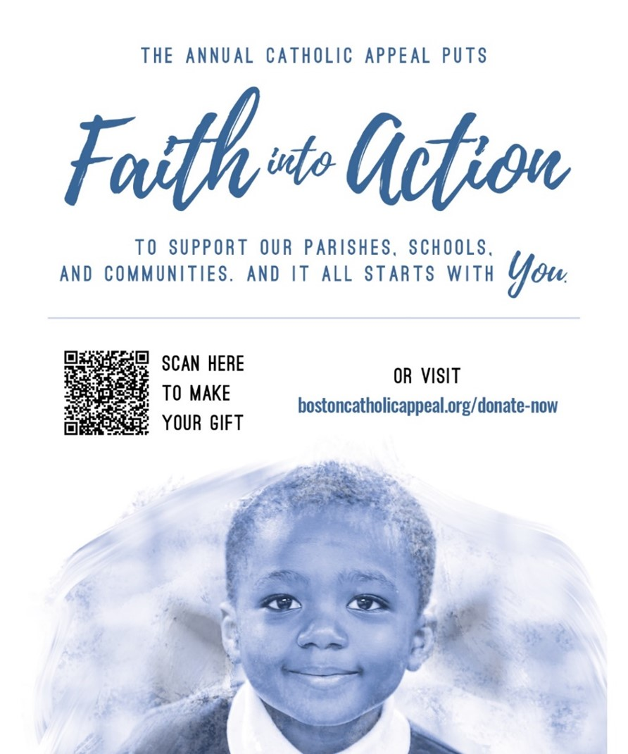
Sample Bulletin Announcement:

I am pleased to share that PARISH NAME has raised $X toward our 2022 Catholic Appeal goal of $X. Thank you to all who have helped make our campaign a success. If you have yet to give, we need your help! Please give today to help us reach goal by XX/XX/XX. Gifts can be made online at BostonCatholicAppeal.org or by completing a pledge form available at the Church exits. On behalf of Cardinal Seán O’Malley and all who will benefit from your generosity, thank you for your support.

- Send an email to your parishioners, asking for their support.

- Add a link to our donation page or a QR code to make giving easier.

- Include the Catholic Appeal in the Prayer of the Faithful.

Sample Prayers of the Faithful:

- That our sacrificial gifts to the Catholic Appeal will enable its many ministries to spread the Gospel message and give aid and comfort to those in need here at PARISH NAME and throughout the Archdiocese of Boston.

- For the special intentions of all those who have supported PARISH NAME’s 2022 Catholic Appeal campaign. May their sacrifice strengthen our parish community and draw us ever closer to the heart of Jesus.

Thank you for all you do to support the Catholic Appeal at your parish.

We are here to help.
If you have any questions please contact
Arlene Dubrowski at 617-779-3706 or Adubrowski@rcab.org.

