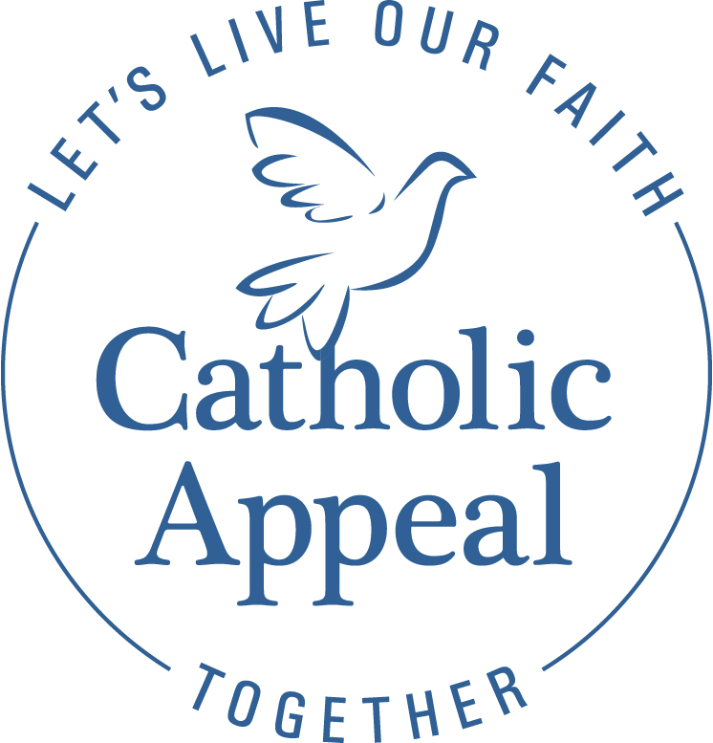
2022 Catholic Appeal

Thank you for our continued support of the Catholic Appeal.

As we close our campaign, now is great time to thank your parishioners for their support of the 2022 Catholic Appeal.
Whether you have met your parish goal or not, please use this as an opportunity to show appreciation and gratitude for their generosity.

- Provide an update from the pulpit on progress to date and request support from those who have yet to make a gift or pledge.

Back in March we launched our Catholic Appeal Campaign here at XXX parish. Your response has been enthusiastic. I am proud to report that our parish has raised $XX towards our goal of $xx. Thank you. The Catholic Appeal provides all of us with an opportunity to make a commitment to the larger Church and the many ministries that support so many throughout our Archdiocese. Your generosity to the Annual Catholic Appeal helps to lead the way in the Church’s efforts to care for the poor, improve our ability to identify and treat mental illness challenges (particularly among our young people), bolster our schools and faith communities – and so much more.
Again, thank you. Your support of the Catholic Appeal has never been more important. Your generousity provides much needed resources and care for thousands throughout our Archdiocese. Thank you for your generosity.

- Include an announcement in your parish bulletin.
Congratulations! PARISH NAME has raised $XX towards our 2022 Catholic Appeal goal of $XX. I am truly grateful to the XX parishioners and families that helped us reach this important milestone. The Catholic Appeal makes a meaningful difference in putting faith into action to support the parishes, schools, and communities within our Archdiocese. Thank you for your generosity and commitment to our parish and to our Church.

- Include the Catholic Appeal in the Prayer of the Faithful.

Sample Prayers of the Faithful:

- That our sacrificial gifts to the Catholic Appeal will enable its many ministries to spread the Gospel message and give aid and comfort to those in need here at PARISH NAME and throughout the Archdiocese of Boston.

- For the special intentions of all those who have supported PARISH NAME’s 2022 Catholic Appeal campaign. May their sacrifice strengthen our parish community and draw us ever closer to the heart of Jesus.

Thank you for all you do to support the Catholic Appeal at your parish.
We are here to help. If you have any questions please contact
Arlene Dubrowski at 617-779-3706 or Adubrowski@rcab.org.

