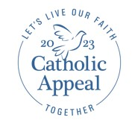
2023 Catholic Appeal
Bulletin Announcements, Box Ads and Banners, Prayers of the Faithful for your campaign launch

Below are some options for you to insert in your weekly bulletins to help launch your parish Catholic Appeal campaign. Thank you again for helping spread the word about the 2023 Catholic Appeal! If you have any questions, please feel free to reach out to Arlene Dubrowski at catholic_appeal@rcab.org
For the weekend of February 18-19
Faith in Action. It all starts with YOU.
One of the most meaningful ways that we deepen the impact of our Archdiocese’s schools, parishes, and ministries is by supporting the Catholic Appeal. The Appeal is a primary means by which we carry Christ’s light into darkness and deepen the impact of our Church’s ministries, many of which directly benefit our parish. Your partnership and participation carry Christ’s love into our communities in numerous ways.
Many of you may have received a letter from Cardinal Seán requesting your early support of the 2023 Catholic Appeal. We hope that you will respond to his invitation with a generous gift, knowing that each contribution transforms faith into action. Thank you.

Faith in Action. It all starts with YOU.
Once a year, Catholics throughout the Archdiocese are asked to partner with one another to support their parish and the many outreach ministries by contributing to the Catholic Appeal. Many of you have received a letter from Cardinal Seán requesting your early support of the 2023 Appeal. We hope that you will respond to his invitation with a generous gift, knowing that each contribution transforms faith into action. You can make a gift by returning your pledge card or by making an online donation at www.bostoncatholicappeal.org/donate-now. For those who have already made a gift, thank you for your early support! The Appeal is a primary means by which we care for our brothers and sisters, and it all starts with YOU.

Weekend of February 25-26
Next weekend, the 2023 Catholic Appeal will officially launch here in our parish and across the Archdiocese. One of the most meaningful ways that we witness the presence of Christ and deepen the impact of our Church’s ministries is by supporting the Catholic Appeal. As your pastor, I invite you to prayerfully consider extending your generosity to this year’s appeal. Many of you have already done so and I am deeply grateful. When our parish reaches its goal of $____, a portion of the additional funds received will be returned to us for use in our parish. To make a gift online, please visit www.bostoncatholicappeal.org/donate-now. Thank you!

*Announcement Weekend: March 4-5
*On this weekend, a special insert will be included in the parish bulletins announcing the launch of the Appeal. No additional bulletin inclusion is needed.

Commitment Weekend: March 11-12
We’re very excited to launch the Catholic Appeal this weekend at [NAME OF PARISH]. Thank you to those who have already responded generously to the Cardinal’s invitation! Because of your early support, we have reached % of our goal. As Catholics, each of us shares the responsibility of the Church community – both directly within our parish and to the greater Church. Thank you for responding in faith, hope, and charity by making a gift to the 2023 Catholic Appeal. We are stronger together and your generosity is greatly appreciated!

Box ads and banners. These are available in English, Spanish, Portuguese, and Haitian Creole and can be found in pdf or jpg versions on the “For Parishes” tab at www.bostoncatholicappeal.org
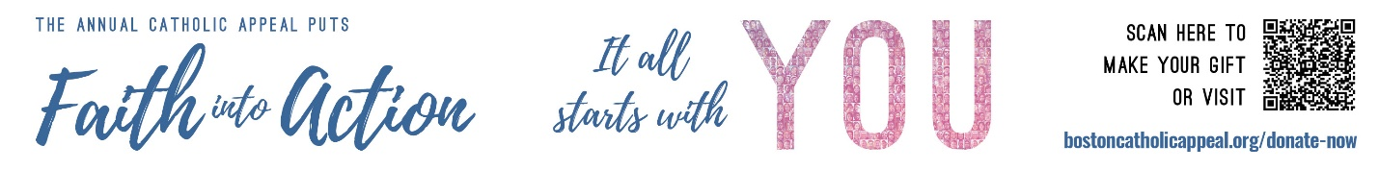

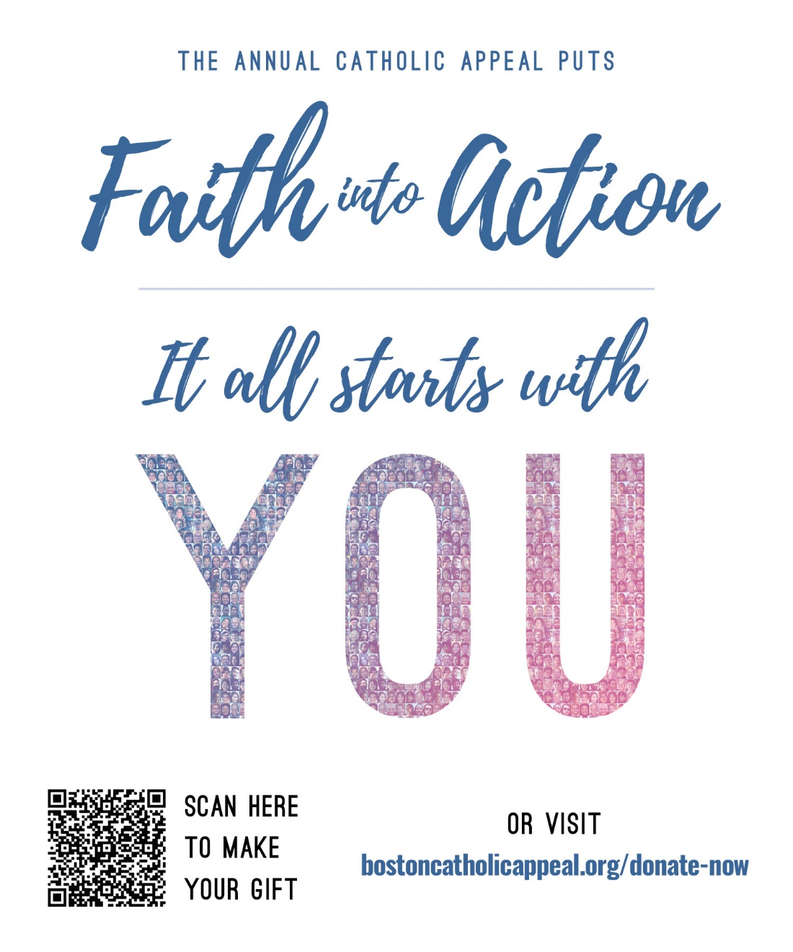

Prayers of the Faithful
The following are some Prayers of the Faithful that you may want to consider adding to your Masses:
- That our gifts to the Catholic Appeal will continue to serve and support our PARISH NAME as well as our Catholic schools, our communities, and our brothers and sisters in need.

- That in our unified efforts to support the Catholic Appeal, our parish programs and ministries will be enriched here at PARISH NAME as, together, we put our faith into action.

- That generosity and love will fortify the Catholic Appeal’s life-changing ministries and programs, especially those that directly affect our parish.

