How to find embed code to get the 2023 Catholic Appeal video on your website!
Embedding allows you to take your video — or someone else's video — and post it on a web page outside of Vimeo. For example, you can embed a video on your website and then people can watch your video there without having to visit Vimeo.
Go to the vimeo site and find the 2022 Catholic Appeal video. Here is the link:
https://vimeo.com/796328040
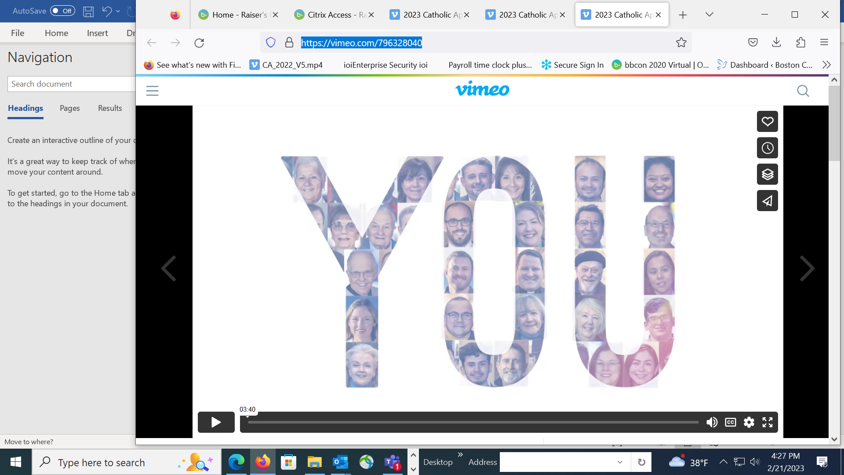
- Share

- Click the “Share” button on the video

- copy text :
2. Copy text
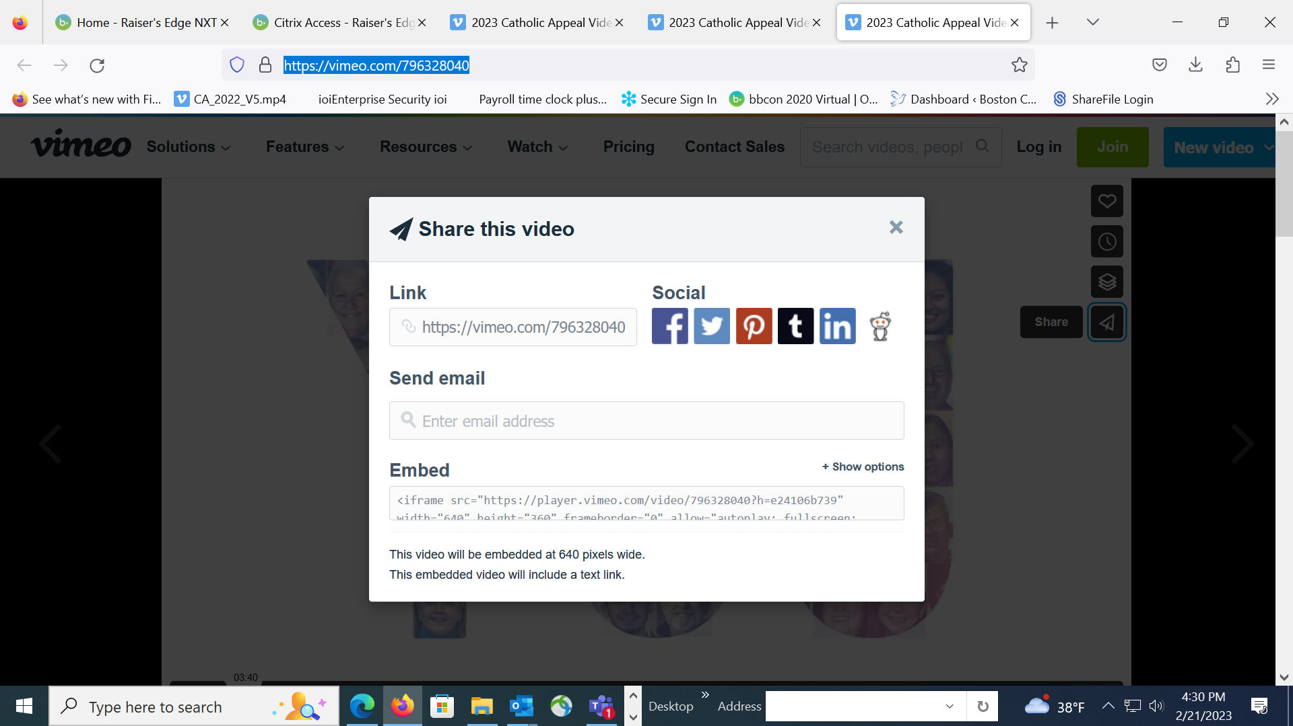

- Go into the text box under “Embed” and copy ALL of the text.
- Paste that text into your website and the video will be embedded!
Thank you for sharing the 2023 Catholic Appeal video!

