2024 Catholic Appeal

2024 Catholic Appeal: Commitment Weekend March 9-10, 2024
Below is a script that will guide you through the in-pew process. Pastors are strongly encouraged to personalize their presentation to increase its effectiveness. The more effectively you connect the Appeal with a message that will resonate with your parishioners, the more likely they will respond. The Annual Catholic Appeal Office strongly recommends that all parishes conduct the in-pew solicitation on Commitment weekend March 9-10 in order to maximize the parishioner’s opportunity to participate.

Pastor In-Pew Presentation
For several weeks now, you have heard about the launch of the 2024 Catholic Appeal. You may have already received a letter from Cardinal Sean and last week we heard from [NAME OF WITNESS TALK PRESENTER] who encouraged us all to give a gift.
Today is my turn. For a few moments, I want to tell you why I support the Catholic Appeal and how it helps our parish, and many other important ministries thrive.
Last year, the Catholic Appeal helped our parish by ……
[Share a parish story]
Reemphasis of Offertory vs. Appeal
The Catholic Appeal is not the same as our parish Weekly Offertory. The Offertory helps pay our parish utilities, insurance, staff salaries, etc. The Catholic Appeal pays for the work of the Central Ministries, ministries that provide invaluable aid to parishes like ours but also essential ministries throughout the Archdiocese.
Imagine: The Archdiocese of Boston covers nearly 2500 mi² and is the 4th largest diocese in the United States. It includes nearly 250 parishes, 93 Catholic schools, and 88 ethnic communities! It develops, implements, and supports services that reach thousands of people, Catholics and non catholics alike, each year. As you can imagine, each year the need grows as new challenges arise and old challenges (like the aftereffects of the pandemic) continue. The Appeal allows us to create new beginnings, provide second chances, and develop possibilities.
In many ways, the Catholic Appeal is the heartbeat by which many lives are sustained and strengthened.
Our parish has always fostered a culture of mercy and responded beautifully when asked to help people in need. With this spirit of generosity, I am hoping you will respond to the Catholic Appeal’s call to serve our brothers and sisters who are suffering, lonely, and in need of help.
I join Cardinal Sean in asking for 100% participation this year. The need is that great. And our ability to help is that expansive.
The ushers are now distributing envelopes to every family.
I ask you to prayerfully consider- as I have- to give a generous gift to our brothers and sisters in need. Every gift- no matter the size- adds to the collective and has a tremendous impact.
Make a Gift: I am going to give us all a moment to pause now. The pledge envelopes have been distributed. I am going to take a moment to complete my form, I hope that you will too. Please consider a gift or a pledge that makes the most sense for you and your family and indicate your donation preference. Please know that your personal information is confidential and will not be shared with any organization outside the Archdiocese or parish.
Many of you may have already given through the Cardinal’s request letter. Raise your hand if you have. Thank you for your early support. Please indicate that on the card envelope.
It is not necessary to make your full payment today, you can simply make a pledge. You will receive a monthly reminder cards so you can make payments by check, credit card, or online—whatever is most convenient for you.
For those of you who are interested in making an online gift, you can do so by using your mobile device to scan the QR code located on the envelope or on the back of your pew. This will take you to a safe and secure online form to make your gift now. You can give my credit card, paypal or venmo.
It is important to pause and allow parishioners time to complete the form.
Please make sure that you write our PARISH NAME/TOWN on the space indicated so that your gift is properly credited to our parish. If you are visiting from another parish, you may write that parish name and town in the space instead.
Once you’re done completing all the fields on the form, tear it off, place it in the envelope, and seal it.
Pause for 2 Minutes in Quiet
Collection- Ushers are coming around to collect the envelopes. Our volunteers will circulate to collect your pledge envelopes and pencils.
Thank You
I am so grateful to you and so proud to be your pastor. I know that we are often asked to donate to many different organizations. But when we donate to the Catholic Appeal, we have an opportunity to lift people out of indifference. Together, we can foster connections with one another, even with people we will never meet. Together, we can live our faith and bridge the gap between worry and hope.
I lift you all in my prayers of gratitude every day for your generosity and your faithfulness. On behalf of Cardinal Sean and all those who benefit from your generosity. Thank you.

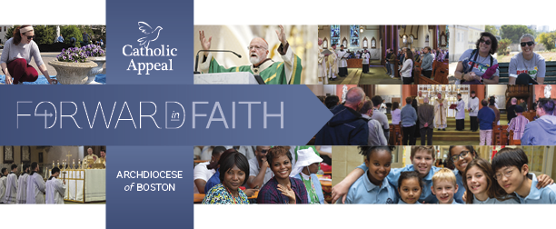

Thank you for your continued support.
We are here to help.
Should you have any questions, please email: Catholic_Appeal@rcab.org

