2024 Catholic Appeal
Bulletin Announcements.

After your parish campaign has launched, be sure to thank and update your parishioners with a bulletin announcement. Below are some options for you to insert in your weekly bulletins regarding the Catholic Appeal. These reminders have proven to be helpful in our Appeal efforts and we are very grateful for your support!
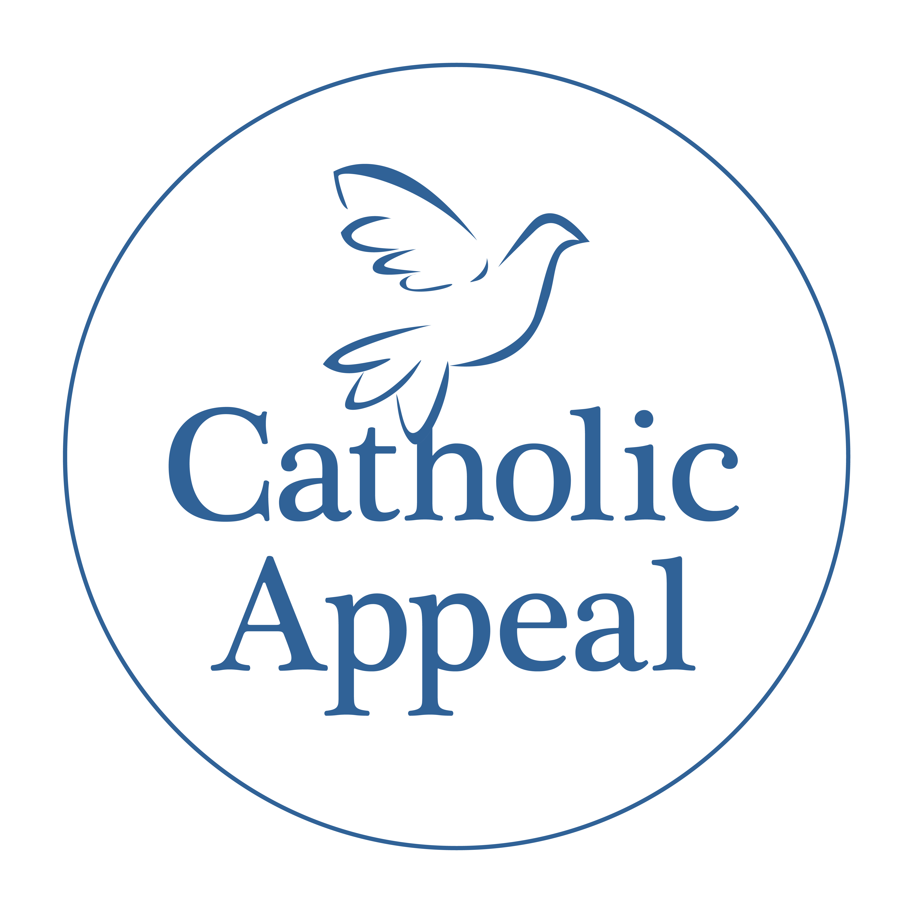
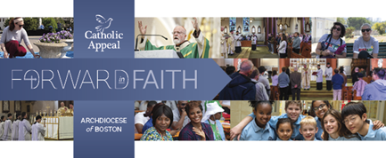
CA Bulletin Ad Options
Post Launch Bulletin Announcements
Moving Forward in Faith… Together
The Catholic Appeal is a way that we can fortify, sustain, and expand the many ministries and services that serve thousands across the Archdiocese. We are so grateful to all of you who have helped launch a successful 2024 Catholic Appeal campaign here at PARISH NAME. To date, we have raised $XX , which means we are at XX% of our goal. Thank you for responding in faith, hope, and charity by making a gift to the 2024 Catholic Appeal. We are stronger together and your generous participation is greatly appreciated! If you have not had a chance to do so, please consider making your gift to the Appeal today by picking up an envelope at the back of the church or make an on-line donation at www.bostoncatholicappeal.org. Participation from every household in the parish is important and every gift makes a meaningful difference in moving us Forward in Faith to support the parishes, schools, and communities within our Archdiocese. Thank you.
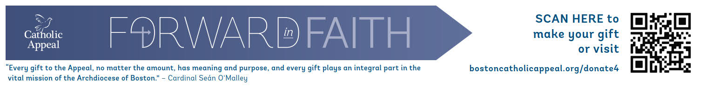
Post Launch Bulletin Announcement 2
Forward in Faith
Once a year, Catholics throughout the Archdiocese are asked to partner with one another to support their parish and the many outreach ministries by contributing to the Catholic Appeal. I am pleased to share that our parish has raised $XX toward our 2024 Catholic Appeal goal of $XX. More importantly ## parishioners have participated in our parish campaign. Our heartfelt thanks to all who have helped make our campaign a success so far.
If you have not had the opportunity to support the Appeal yet, I invite you to make your gift today to help us reach our goal. Pick up an envelope at the back of the church or make an on-line donation at www.bostoncatholicappeal.org. Your participation in our Appeal is appreciated by our parish and all those who are served by the ministries funded by the Appeal that moves us Forward in Faith in support all of our parishes, schools, and communities. Thank you.

Options for Prayers of the Faithful
The following are some Prayers of the Faithful that you may want to consider adding to your Masses:
- That our gifts to the Catholic Appeal will continue to serve and support our PARISH NAME as well as our Catholic schools, our communities, and our brothers and sisters in need. We pray to the Lord.

- That in our unified efforts to support the Catholic Appeal, our parish programs and ministries will be enriched here at PARISH NAME as, together, we move forward in faith. We pray to the Lord.

- That generosity and love will fortify the Catholic Appeal’s life-changing ministries and programs, especially those that directly affect our parish. We pray to the Lord.

Thank you again for helping spread the word about the 2024 Catholic Appeal! If you have any questions, please feel free to reach out to Arlene Dubrowski at catholic_appeal@rcab.org.

