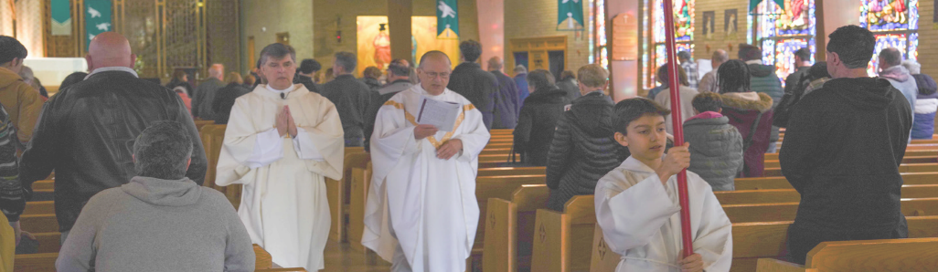
2024 Catholic Appeal
DONATION PROCESSING

All Catholic Appeal donations received at the parish should be submitted as soon as possible for processing using the envelopes, bank bags, and FEDEX materials sent to your parish.
Notify parish staff and volunteer counters of the special processing of Catholic Appeal donations.
- Store all envelopes and donations in a secure location until they can be sent for processing.
- Ensure your parish number is written on the outside of all envelopes to ensure your parish receives credit for each donation

PREPARING DONATIONS RECEIVED AT YOUR PARISH:

IN PEW ENVELOPES
- FOR THE PURPOSE OF DONOR SECURITY, PLEASE DO NOT OPEN ENVELOPES FOR ANY REASON.
- Write your three-digit parish number on the outside of all envelopes to ensure your parish receives credit for each donation.

LOOSE COINS/BILLS NOT ENCLOSED IN ENVELOPE:
- Tally all loose coins/bills and deposit into your parish account.
- Write a check from your parish account made payable to “The Catholic Appeal” for the corresponding amount.

LOOSE CHECKS RECEIVED WITHOUT ENVELOPE
- If the check is made out to the parish: Simply write “pay to the order of the Catholic Appeal” on the back of the check and include a signature from an authorized signatory of the parish.
- If the check is made out to the Catholic Appeal: you do not need to write anything on the check.

ON-LINE DONATIONS

To your parish giving page.
- For on-line donations: Write a check for the total donations. Send the check along with a listing of each donor’s name, address and amount. Without this information, a thank you acknowledgement and tax receipt cannot be sent to the parishioner.

SHIPPING DONATIONS FOR PROCESSING
Bundle all unopened in-pew envelopes and checks together. Place inside the FEDEX envelope and attach label for mailing to our lockbox agent: Datamatix, Inc., Be sure to retain a copy of the FEDEX air bill for tracking purposes.
Drop your package in the nearest FEDEX bin.
To look up the location of the nearest FEDEX bin go to FEDEX.com.
Any Donations that require special handling should be mailed to:
Catholic Appeal Office Attn: Wendy Bartlett 66 Brooks Drive
Braintree, MA 02184
Gift Processing Updates and FAQ

Donors often call the parish with questions about their Catholic Appeal donations. Below are some frequently asked questions to assist you, or you can always contact the gift processing team at 617-779-3700.

Parishioner Question | Response
Parishioner is receiving duplicate, inaccurate, or unwanted mailings | Please email or call us with the details so that we can update our records:  catholic_appeal@rcab.org or 617-779-3700
Parishioner’s check to the Catholic Appeal has not cleared OR parishioner made a donation, and it is not listed on your donor report | Contact our office to ensure we are not behind with our gift processing at 617-779-3700 OR catholic_appeal@rcab.org  **PLEASE NOTE: at the launch of the Appeal, it is not uncommon to have a three week processing delay.
Parishioner needs to change their credit card information | Please advise parishioners to use proper security when updating their credit card. Card information should never be sent via fax, email, or left in a voice message. Contact the Catholic Appeal office at 617-779-3700 and we can make the necessary changes.
Parishioner made an electronic gift on the parish website meant for the Catholic Appeal | Transfer the money into the Parish account and send a check, made payable to “The Catholic Appeal.” Please include parishioner’s name and address for proper processing and acknowledgement.

For questions regarding parish reporting, donor updates, gift processing, Appeal materials, rebates, abatements, or issues accessing the Catholic Appeal website, please contact:

Arlene Dubrowski
Catholic Appeal Manager
617-779-3706
adubrowski@rcab.org

